Common Allocation Policy Review 2023
Policy Review

A joint approach to housing in Drumchapel involving:

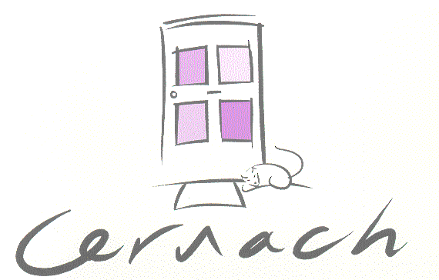

A Common Allocation Policy is where a group of social landlords agree to use the same set of rules to let their homes.

Our Common Allocation Policy is due for renewal and as part of this review we need to consult with our tenants, applicant’s for re-housing and interested groups / organisations. The proposed updated Common Allocation Policy can be viewed at each of the 3 landlord’s websites or on request from our offices.

There are only minor changes to the policy proposed at the moment. These are:
- Section 6.1 Legal Framework – to add the Domestic Abuse (Scotland) Act 2011 & 2018
- Section 9.3 – to add that you can complete an online application form at www.drumcog.org.uk

We would like to hear your views on how we allocate homes

We are keen to hear your views in order for us to consider your feedback in our policy review. Please therefore consider the following questions: -

Having viewed the policy do you think it is clear, easy to read and understand?

YES NO

If no, please state how we can improve the policy:

Any other comments you would like to make regarding the proposed policy:

Thank you for taking the time to complete this survey and taking part in our consultation – it is much appreciated.
And finally, can you indicate (choose 1 only) whether you are responding as:

A tenant of one of the landlords

An applicant of one or more of the landlords

An interested group or organisations

Please return your form by 30th October 2023 to any of the 3 landlord offices, return by email or call us at any of our offices with your responses. You can also complete the survey online on our websites.

Cernach Housing Association,
Marion MacDonald House
79 Airgold Drive, Drumchapel, Glasgow
G15 7AJ 0141 944 3860
admin@cernachha.co.uk
www.cernachha.co.uk

Kingsridge Cleddans Housing Association,
Commercial Units 2/3, Ladyloan Place,
Drumchapel, Glasgow, G15 8LB
0141 944 3881
admin@kc-ha.com
www.kc-ha.com

Pineview Housing Association
5 Rozelle Avenue
Drumchapel
Glasgow
G15 7QR
mail@pineview.org.uk
www.pineview.org.uk

